
Test 2

Proportion, Functions, Relations & Transformations

Semester One 2019
Year 11 Mathematics Methods
Calculator Assumed

Name:
Teacher:

Date: Friday 12th April 7.45am

You may have a formula sheet and 1 page (1 side) of notes for this test.

Total___________/ 41 Total Marks:41 Time: 45 Minutes

Question 1 (3 marks)
State whether the following relations are functions.
- {(0, 0), (1, 1), (1, -1), (4, 2), (9, 3)}

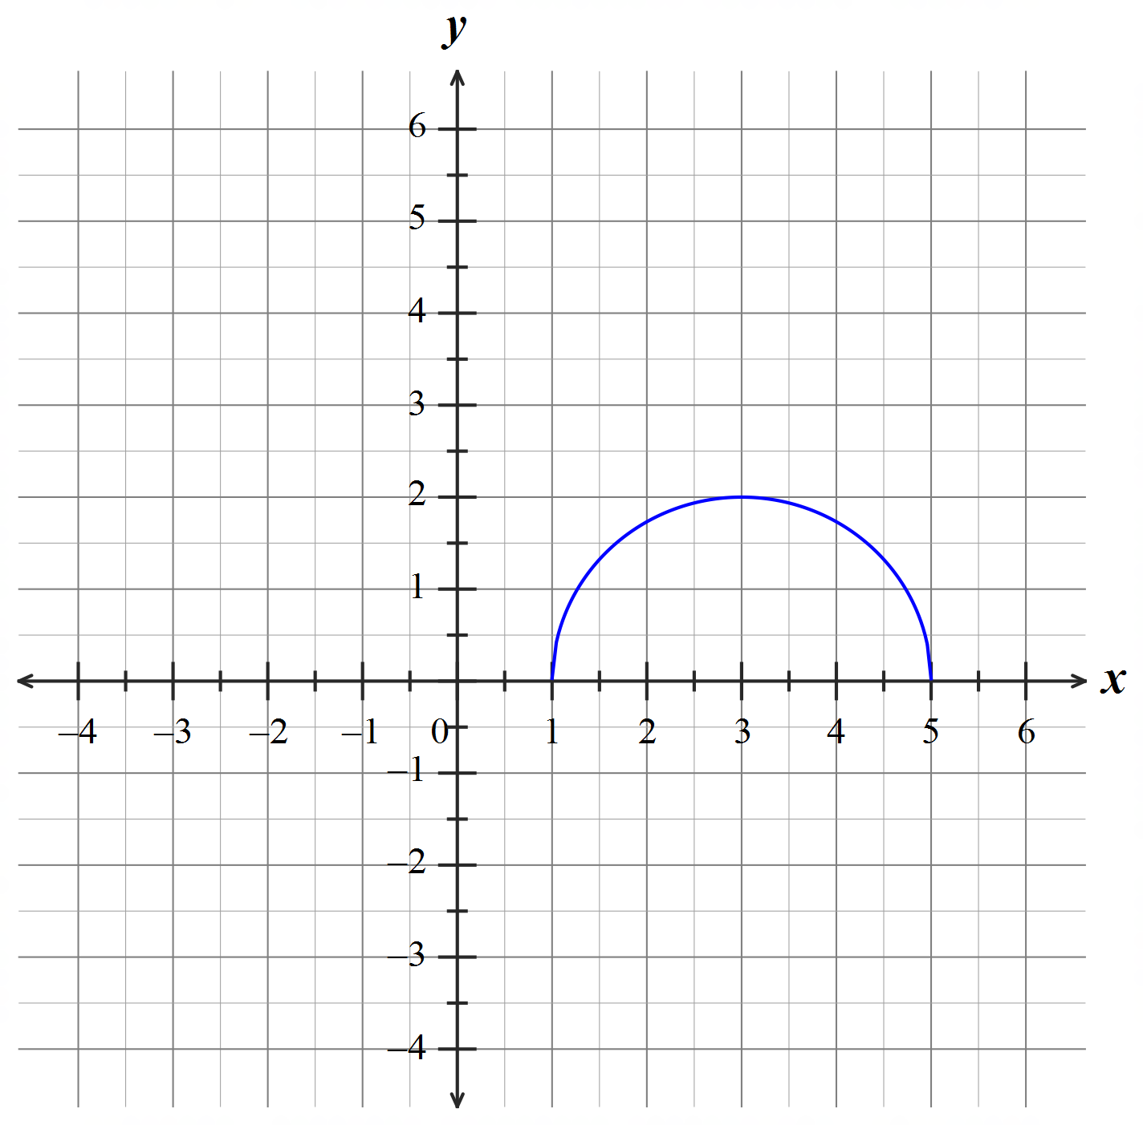

- 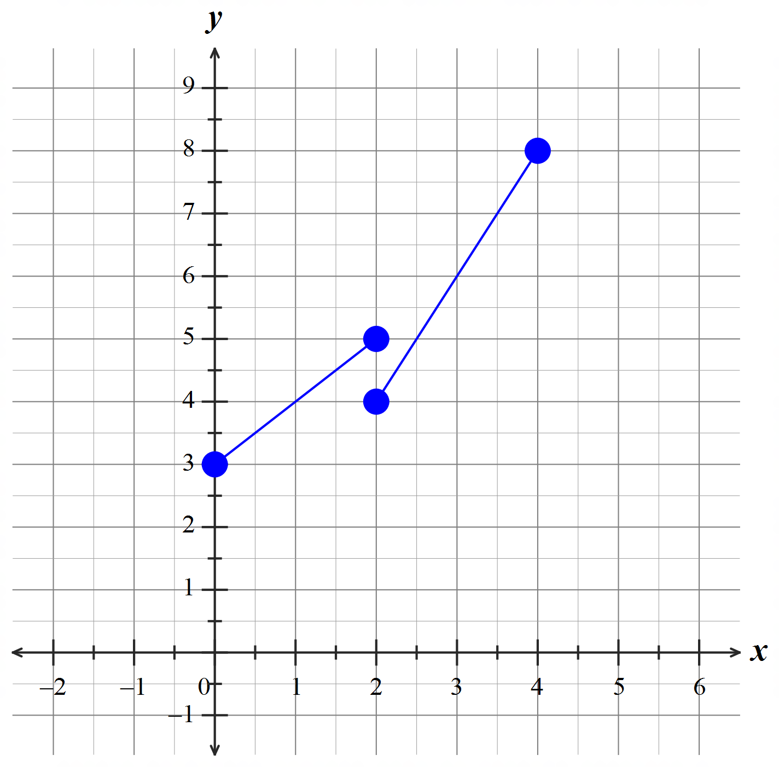

Question 2 (4 marks)
Given that $y$ is directly proportional to the square of $x$. When $y = 12$, $x=4$, find
- the constant of variation (2 marks)

- the value(s) of x when y = 27 (2 marks)

Question 3 (8 marks)
- Find the radius and the coordinate of the centre of the circle with equation $x^{2}+y^{2}-4x-6y-3=0$. Show your working. (3 marks)

- The variables $x$ and $y$ are related as demonstrated by this graph.
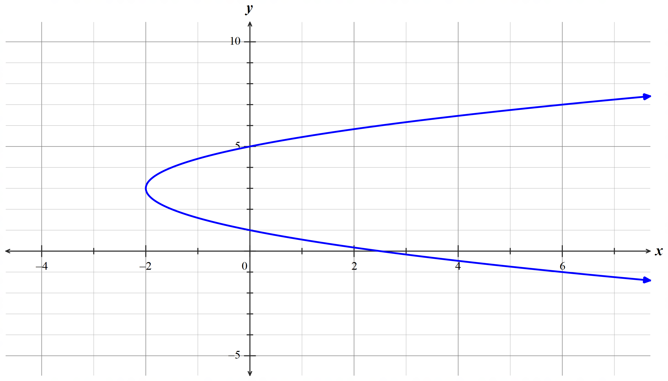

- Determine the equation of the graph above. (3 marks)

- State the domain. (1 mark)

- From (a) and (b), what features of their graphs clearly indicate that $x$ is not a function of $y$? (1 mark)

Question 4 (6 marks)
The function $f\left(x\right)=\sqrt{x}$ is transformed into $g\left(x\right)=k\sqrt{(ax+b)}+c$ by the following sequence of transformations.
- Sketch the following transformation of $f(x)$.
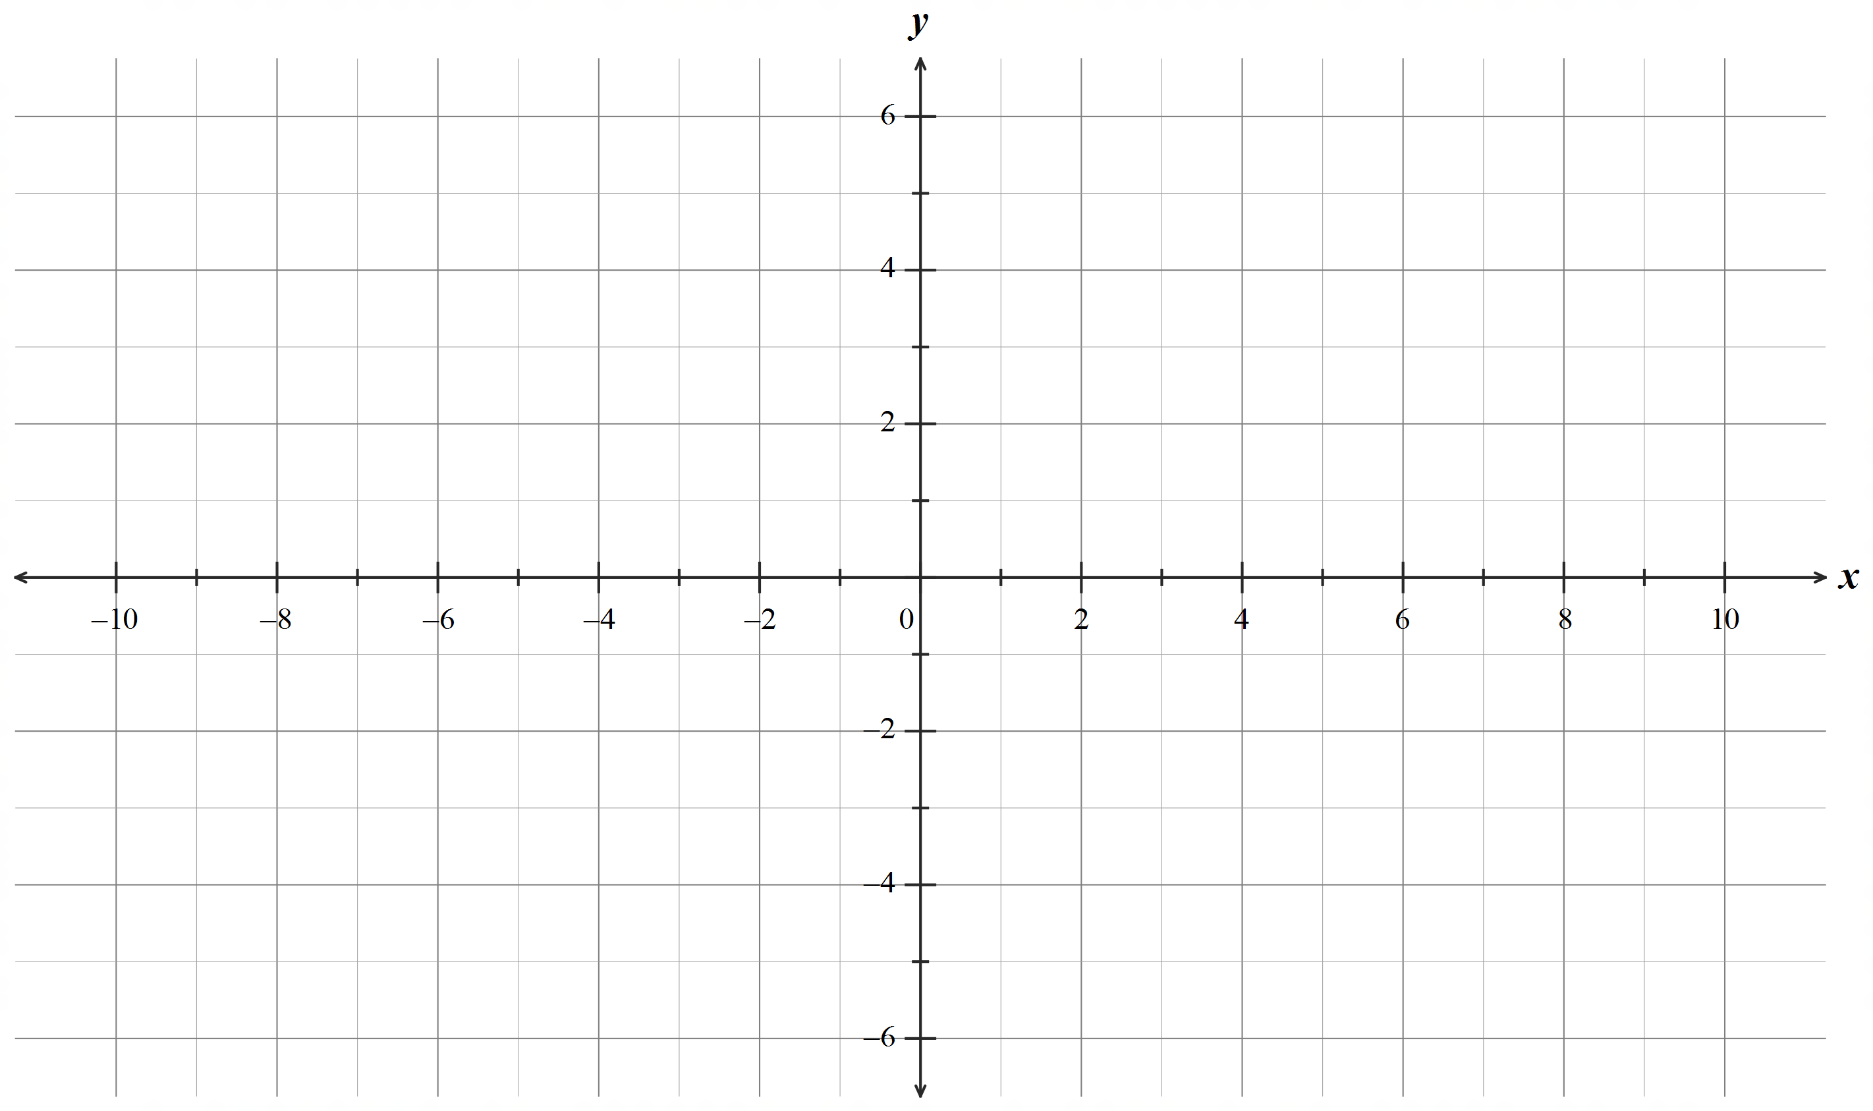‘A translation 5 units in the positive $x$-axis followed by a translation of 2 units in the positive $y$-axis.’ (2 marks)

- Determine the equations of the resulting function $g(x)$.
- A translation 3 units in the direction of the negative $y$-axis followed by a reflection about the $x$-axis. (2 marks)

- A dilation parallel to the positive $x$-axis of factor 2 followed by a translation 4 units in the direction of the positive $x$-axis (2 marks)

Question 5 (9 marks)
Consider the functions $f$ and $g$ where $f\left(x\right)=ax^{2}+bx+c$ and $g\left(x\right)=f(2x+3)$.
- Given $f\left(-2\right)=0, f\left(5\right)=0$ and $f\left(2\right)=3$, determine the rule for $f\left(x\right)$. (3 marks)

- Express the rule for $g(x)$ as a polynomial. (3 marks)

- The coordinate $(1 , 3)$ lies on $f\left(x\right)$. Determine the coordinate for $f\left(x\right)-4$. (1 mark)

- Describe the sequence of transformations that would transform $f\left(x\right)$ to $g\left(x\right)$. (2 marks)

Question 6 (4 marks)

The time (t) in hours required to construct a retaining wall varies inversely to the number of workers (w) being employed. An engineer estimates that it will take 8 workers 180 hours to construct a retaining wall. [Assume that all workers work at the same rate.]

- If the retaining wall must be constructed in 150 hours, how many extra workers will need to be employed? (3 marks)

- If only 6 workers are available, how long will they take to construct this wall? (1 mark)

Question 7 (7 marks)

- Express $f(x)=\frac{6x-15}{x-3}$ into the form $f(x)=\frac{a}{x-h}+k$. (2 marks)

- Determine the coordinate of the $x$-intercept. (1 mark)

- State the asymptotes of $f(x)$. (2 marks)

- Hence, determine the range of $f\left(x\right).$ (2 marks)

END OF TEST

